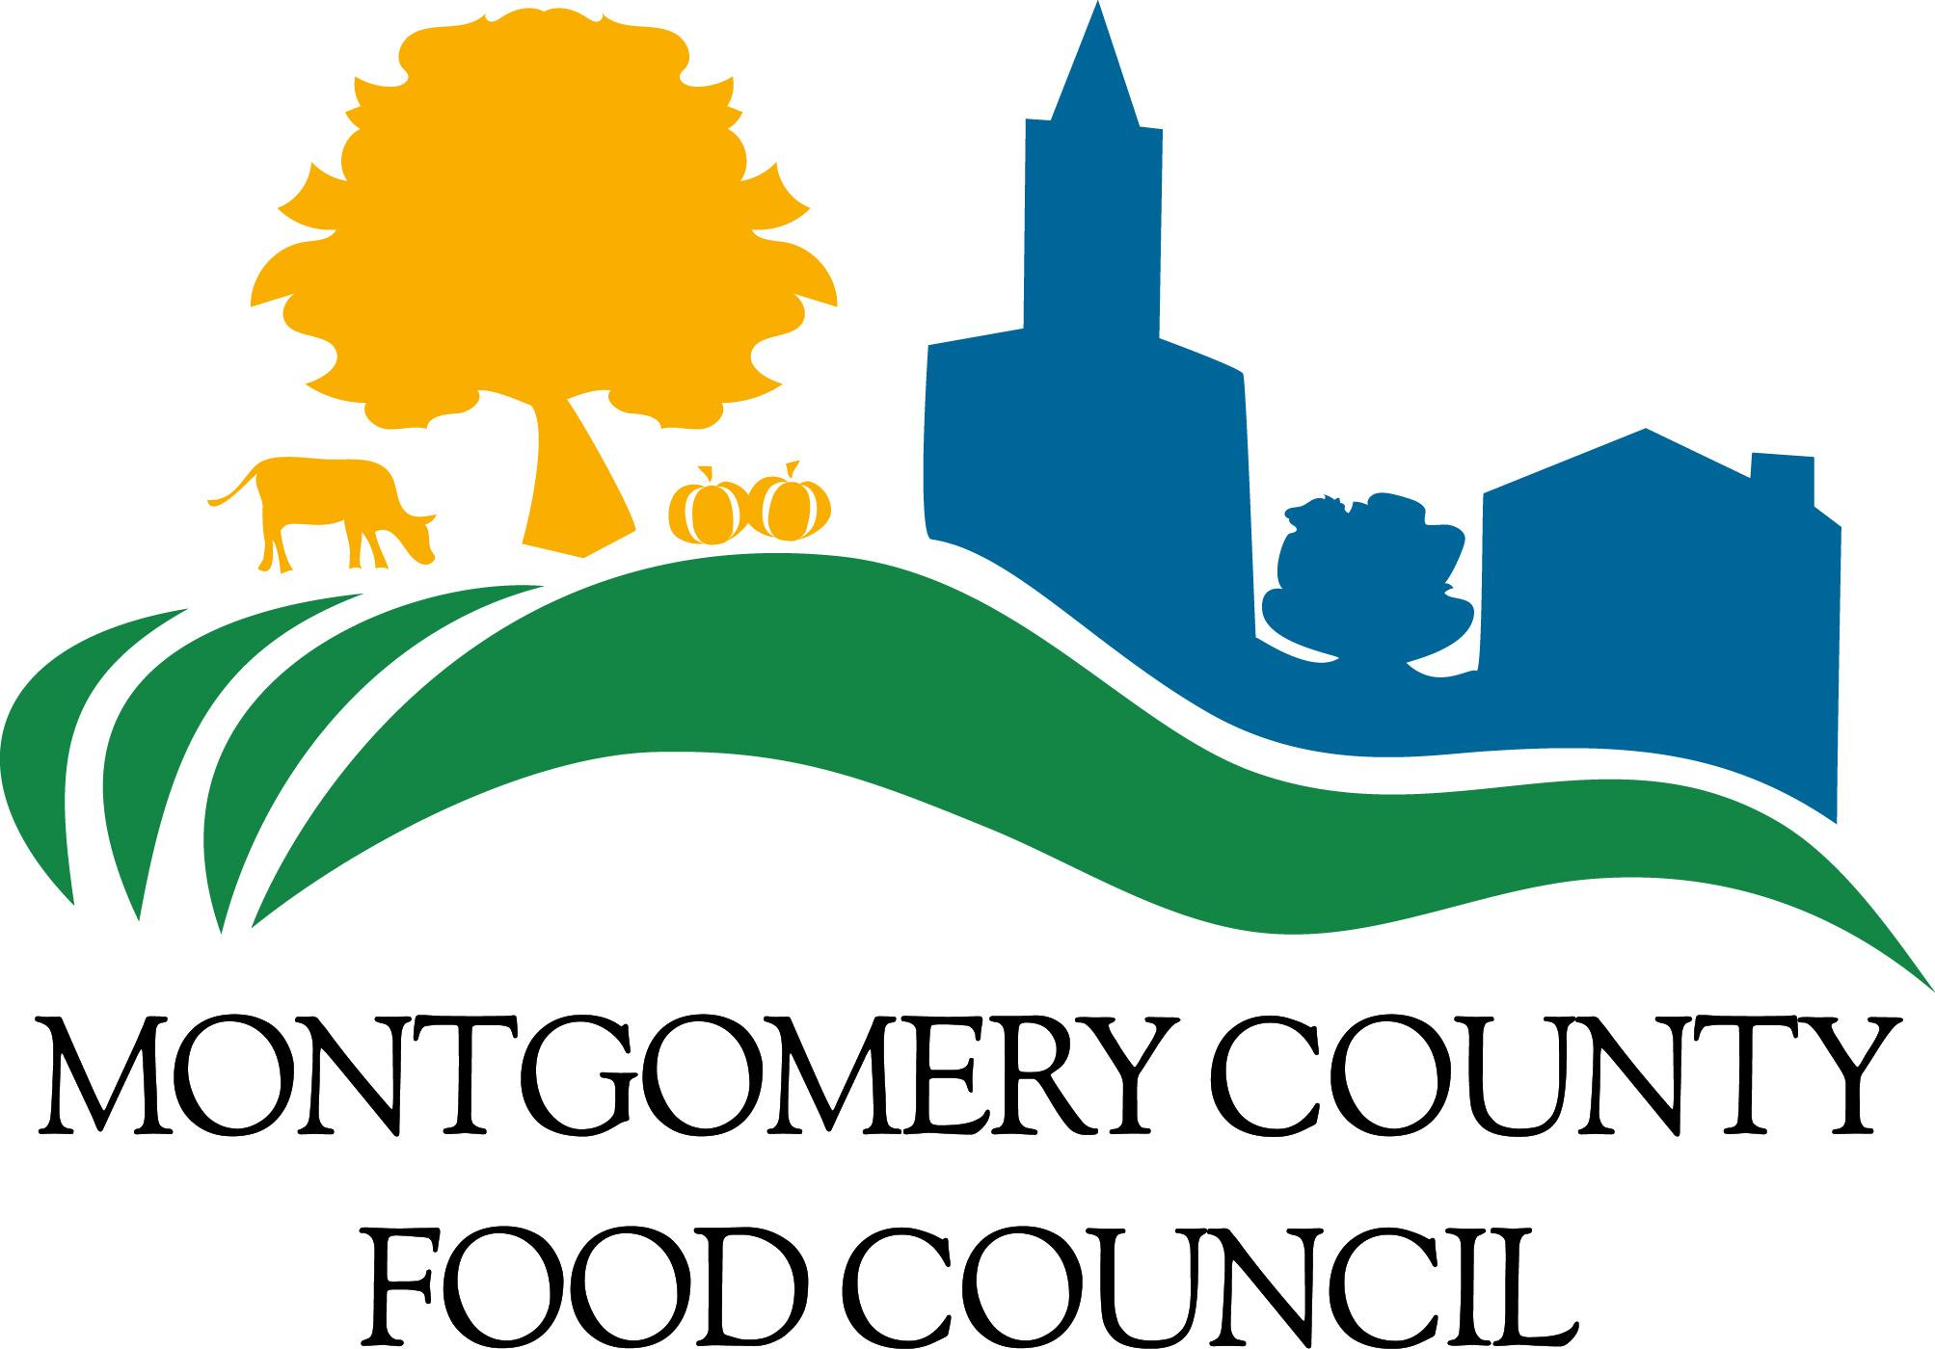
Program Intern
Position Hiring Immediately
Posted August 15, 2023

Apply at jobs@mocofoodcouncil.org
www.mocofoodcouncil.org
MCFC is the primary convener of businesses, nonprofits, government agencies, and residents around food system issues in Montgomery County, connecting 2,000+ partners in education, advocacy, and collaboration building initiatives. Our work cultivates a more resilient, sustainable, and equitable local food system by enhancing food access for the 100,000+ residents at risk for hunger, expanding food education for residents, supporting County farms and food/beverage businesses, and addressing the environmental impact of local food production, distribution, consumption and recycling.
The MCFC staff is a small team of 10 who collaborate closely with 25 volunteer Council Members and 400+ active working group partners. MCFC strives to cultivate a collaborative, supportive, and transparent work environment where all employees have opportunities to develop and apply new skills, independently shape and implement initiatives, and build partnerships with broad and diverse community stakeholder groups.
Position Description:
We seek a self-motivated, skilled, and goal-oriented individual who is passionate about food system initiatives for a Program Intern position. The Program Intern will work closely with Food Council staff members to provide programmatic support to the Food Council’s priority areas, including food security, environmental sustainability and food waste reduction, agriculture and economic opportunity, food education, and food system advocacy.
Duration: October 2nd - December 15th, 2023
Hours per week: 10 - 12, flexible schedule available
Hourly rate: $15 - $18/hr depending on experience
Location: Primarily remote with some in-person hours at community and Food Council events.
We are accepting applications on a rolling basis, but plan a first-round review of applications on September 15, 2023.
Responsibilities include, but are not limited to, the following areas:
- Provide administrative support and complete projects related to the Food Council’s priority areas, including the Policy Priority Working Groups, the MoCo Made Program, the Food Security Community Advisory Board, the Food Security Program, Policy and Advocacy, and Communications. These projects may include researching food system issues, creating informational resources and communications pieces for partners and the public, updating information for use on the website and in databases, meeting and event coordination, etc.
- Provide administrative and coordination support to the Food Council staff, Members, and Board as needed.
- Contribute at Food Council meetings, support the achievement of staff and organizational goals, and interact with the Food Council on projects.
- Attend and provide support at Food Council Internal Meetings and represent the Food Council to the general public at other community engagement and educational events.
Requirements:
- Strong verbal and written communication skills
- Excellent organizational skills and attention to detail
- Proficiency in Microsoft Office Suite and Google Drive
Preferred:
- Currently pursuing a Bachelors or Masters degree in a related field
- Demonstrated interest in food systems
- Relevant prior work or volunteer experience
The successful candidate will be expected to provide their own computer with internet, telephone for communication, and transportation. Access to an automobile is recommended but not required.
Application Process:
To apply, please email a cover letter and resume to jobs@mocofoodcouncil.org by September 15th with the subject line “Program Intern.” Cover letters should include a summary of the candidate’s relevant experience and connection to the Montgomery County community (if applicable). No phone calls please.
The Food Council is committed to building equity in a food system that has, since its very beginning, established and reinforced structural racism and social injustice. We strive to create and strengthen pathways for those who have been marginalized by our food system to direct the policies and programs that will build a more equitable system. The MCFC prioritizes the expertise and leadership of people of color in facilitating systems change and building a team that reflects the diverse population of Montgomery County’s communities. We actively encourage and seek applications from Black, Indigenous, and people of color and members of the LGBTQ+ community. We also encourage applications from people with these identities or who are members of other marginalized communities. The MCFC is an equal opportunity, affirmative action employer, and is firmly committed to a policy against discrimination based on age, sex, race, religious creed, sexual orientation, gender identity, disability or ethnic or national origin.

Learn more about the Montgomery County Food Council at: www.mocofoodcouncil.org.

