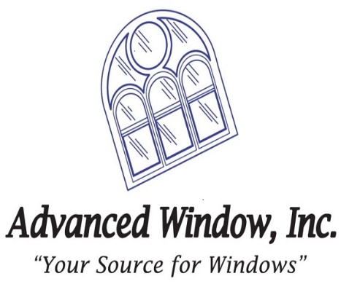
Advanced Window, Inc. (AWI) is looking for several Drafters to join our team in Frederick. AWI was established in 1994 and specializes in sales, consultation, design, engineering, field-testing, installation, and quality customer service of pre-glazed fenestration (window) products. AWI’s focus includes:
- Multi-Family Residential
- Garden Style Apartments
- Mid-Rise
- High-Rise
- New Construction
- Rehabilitation
- Historic
A Drafter with AWI will prepare shop drawings for the use of our products in large, multi-story buildings primarily within MD, DC, VA. This role will require a growing understanding of design principles, computer-aided drafting technologies, and building codes to ensure that drawings are accurate and to present necessary information for construction crews, contractors, and zoning/approval bodies.
A Drafter manages their priorities across multiple projects. They communicate with other teams to fully understand the requirements of the shop drawings. On-the-job training for Company standards and rules will be provided.
AutoCAD required; REVIT preferred.
Job Type: Full-time
Salary: From $43,000.00 per year

Benefits:
- 401(k)
- 401(k) matching
- Dental insurance
- Employee assistance program
- Flexible schedule
- Health insurance
- Life insurance
- Paid time off
- Professional development assistance
- Vision insurance
Schedule:
- 8-hour shift
- Day shift
- Monday to Friday
Work Location: One location

