Cultural Preservation Leadership Summit
The Ford Center for Social Justice

1:15 – 1:45 p.m. Friday, March 29
Session Three: Next Generation & The Future Cultural Preservation Movement

Student activists and emerging professionals are critical to the future Black + U.S. cultural preservation movement and the AACHAF. Their leadership and vision can inform how traditional practice should be reimagined for increased cultural relevance and social impact. Hear from a diverse group of students and social impact leaders about their ideas for diversifying the field, amplifying social justice messages, and instilling a national cultural ethic for preserving African American historic places.
Panelists:
- Jenna Dublin, Columbia University; AACHAF Research Manager, Research and Policy Lab
- Jessica Pumphrey, Georgetown University; Mildred Colodny Diversity Scholar & AACHAF Fellow
- Monique Robinson, Morgan State University; HOPE Crew Preservation Practicum
- Daniela Tai, University of Maryland; Mildred Colodny Diversity Scholar & AACHAF Fellow

Moderator:
- Dr. Lonnie G. Bunch, III, Director, National Museum of African American History and Culture, Smithsonian Institution; AACHAF National Advisory Council

Moderator Biography
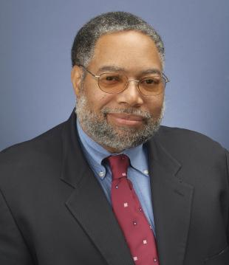
Lonnie G. Bunch III is the founding director of the Smithsonian’s National Museum of African American History and Culture and member of the African American Cultural Heritage Action Fund’s National Advisory Council. Before his July 2005 appointment as director of the National Museum of African American History and Culture, Bunch served as the president of the Chicago Historical Society (2001–2005).

There, he led a successful capital campaign to transform the Historical Society in celebration of its 150th anniversary, managed an institutional reorganization, initiated an unprecedented outreach initiative to diverse communities and launched a much-lauded exhibition and program on teenage life titled “Teen Chicago.” A prolific and widely published author, Bunch has written on topics ranging from the black military experience, the American presidency and all-black towns in the American West to diversity in museum management and the impact of funding and politics on American museums. Lectures and presentations to museum professionals and scholars have taken him to major cities in the United States and many nations abroad, including Australia, China, England, Ghana, Italy, Japan, Scotland, South Africa and Sweden.
Bunch has worked at the Smithsonian in the past, holding a number of positions at its National Museum of American History from 1989 through 2000, and the California Afro-American Museum in Los Angeles from 1983 to 1989. While there, he organized several award-winning exhibitions, including “The Black Olympians, 1904–1950” and “Black Angelenos: The Afro-American in Los Angeles, 1850–1950.” Born in the Newark, N.J., area, Bunch has held numerous teaching positions at the American University in Washington, D.C. (1978–1979), the University of Massachusetts in Dartmouth (1979-1981) and the George Washington University in Washington, D.C. (1989–2000). Among his many awards, he was appointed by President George W. Bush to the Commission for the Preservation of the White House in 2002 and reappointed by President Barack Obama in 2009. In 2005, Bunch was named one of the 100 most influential museum professionals of the 20th century by the American Association of Museums. Bunch received his master’s (1976) and bachelor’s (1974) degrees from the American University in Washington, D.C.
Panel Biographies

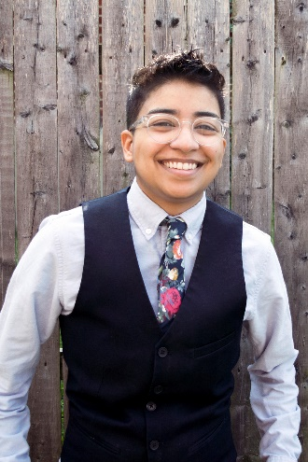
Daniela Tai: Equal parts artist, dreamer, and economist, Daniela Tai is currently pursuing a dual master’s degree in Architecture and Historic Preservation at the University of Maryland. Her class projects at the University include the development of a case statement for the Nina Simone home in Tryon, NC, a reuse study of the Gaston Office Building in Birmingham, and a program reuse plan for the John and Alice Coltrane Home in New York. Tai is the 2018 Mildred Colodny Diversity Scholar and a current African American Cultural Heritage Action Fund Fellow of the National Trust for Historic Preservation. She seeks to bridge preservation, social justice, and urban renewal through the lens of design after graduation. Born and raised in Miami, FL, she originally studied accounting at the University of Florida before setting her sights on impacting the built environment.

Jessica Pumphrey: A 2018 Mildred Colodny Diversity Scholar and a current African American Cultural Heritage Action Fund Fellow of the National Trust for Historic Preservation, Jessica has a bachelor's degree in public relations from Hampton University and is currently pursuing a master’s in public Relations and Corporate Communications at Georgetown University. In her day-to-day, she works as a communications associate at Pew Research Center primarily supporting the social demographic trends and U.S. immigration portfolios. Much of her professional career prior to working at Pew Research Center was at the National Trust for Historic Preservation - where she secured national media placements, engaged Black media, and promote sites like Madam C. J. Walker's Villa Lewaro, A. G. Gaston Motel, Hinchliffe Stadium, and other prominent African American historic places.
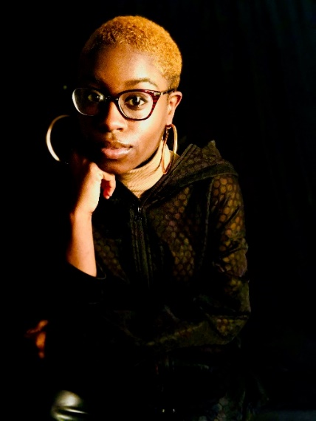
Monique Robinson: A passionate third-year undergraduate student at Morgan State University pursuing a BArch in Architecture & Environmental Design, Monique’s main areas of interests in school include urban design of minority communities, and historic preservation of African American culture. She enjoys learning about the disparities within the African American community and hopes to use her degree to impact their sense of identity and value in a positive way with architecture. Monique serves as the Vice President of Morgan State’s National Organization of Minority Architecture Students chapter and works as an architectural intern at Moseley Architects in Baltimore. She was a participant in the inaugural HOPE Crew ‘Preservation in Practice,’ sponsored by the Advisory Council of Historic Preservation and the National Trust for Historic Preservation at Morgan State University.
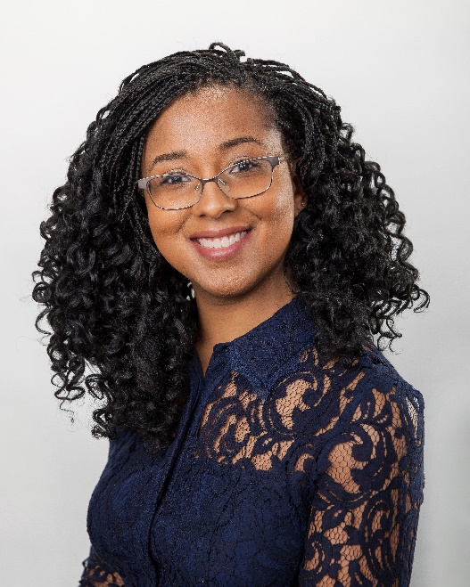
Jenna Dublin-Boc Sor: A fourth year PhD student of Urban Planning at Columbia University, her research examines how and why community-based groups utilize historic district designation to affect neighborhood trends of socioeconomic change and gentrification. Currently, she is a Research Manager at the National Trust for Historic Preservation’s Research and Policy Lab, a current African American Cultural Heritage Action Fund Fellow, and has been a Columbia University Teaching Fellow of urban economics the past two years. In 2016, Jenna participated in the US-ICOMOS International Exchange program where she lived in Delhi, India and contributed to the heritage-based infrastructure upgrading plan for the city of Amritsar, located in northwestern Punjab. Jenna graduated with dual master’s degrees in Urban Planning and Historic Preservation from the University of Maryland, and a Bachelor of Fine Arts degree from the Cooper Union School of Art. She was awarded the Mildred Colodny Diversity Scholarship by the National Trust for Historic Preservation in 2012.
Potential Moderator Questions
Session: 30-minutes
- Dr. Bunch opens with brief introduction to set context for this session. Please refer to panel description listed above. If you need talking points, please let me know.
- Q/A is optional; given the limited time. You shouldn’t feel a responsibility to allow audience questions.
Beyond us showcasing our young thought leaders, this panel offers an important professional development opportunity for them. Keeping these questions broad seems right.
- Tell us about your academic background and your connection to the Action Fund?
- Why you have decided to earn degrees in preservation, architecture, urban planning, or corporate communications? Why is the Colodny Scholarship an important resource for the field?
- Why is it important to preserve Black cultural heritage and the stories they keep?
- How can we inspire other young leaders and students like you to join this movement?
- Over the next 25 years, how will you contribute professionally to this field of practice?
On Friday, March 22, I will convene a call with these four panelists, share the moderator questions, and discuss with them their talking points. Erin Golightly is welcome to join this call.
Background Information
In response to the remarkably low number of African Americans and diverse professionals in the field of historic preservation (less than 5% of Black preservationists are academically trained), the African American Cultural Heritage Action Fund Fellowship Program is a short-term, paid opportunity, designed to give graduate students and emerging/established professionals first-hand experience around the challenging, varied and interesting work of preserving African American historic places, while broadening their network base and increasing the National Trust’s capacity to save places. The fellowship program is:

- Acting as a talent management pipeline for the Action Fund and National Trust;
- Developing the next generation of cultural preservation thought leaders, experts and stakeholders;
- Building a national network of preservation allies across a wide spectrum of industries and professions; and,
- Leveraging the network to advance Action Fund program priorities.

Since launching the Action Fund in November 2017, the National Trust has hired 12 program and research Fellows. Currently, Daniela Tai works in the Preservation Division and Jessica Pumphrey works in Marketing and Public Affairs. The other 10 research Fellows were located offsite, conducted place-based research of Black residential and commercial districts, and wrote case studies for the forthcoming Action Fund report titled Cultural Heritage, Affordability, and Displacement in historically African American neighborhoods. Eight of these 10 Fellows are African American, from an undergrad at Wesley to a PhD student at UCLA. Panelist Jenna Dublin manages these 10 research Fellows for the National Trust’s Research and Policy Lab who’s writing the report. We seek to grow support for and scale up our fellowship program.

Mildred Colodny Diversity Scholarship: Established in 2003, the program provides financial assistance and experiential learning opportunities to individuals preparing for careers in historic preservation. The purpose is to increase the diversity of people pursuing degrees and careers in historic preservation in the United States who ultimately will contribute valuable, diverse perspectives and become leaders in the field. Each year, one national award is granted, totaling nearly $25,000 in benefits. Previous winners include current National Trust staffers Brent Leggs, Monica Rhodes, Lawana Holland-Moore, and Sehila Casper.
UMD Colodny Pilot Partnership: In 2018, the National Trust and the University of Maryland’s Graduate Program in Historic Preservation launched a three-year pilot partnership to recruit diverse students to the UMD program. This effort is to grow a more diverse and equitable field of practice. Daniela Tai was the inaugural UMD Colodny Scholar + AACHAF Fellow of this partnership. She received a $15,000 tuition stipend, $6,000 fellowship, and attended the National Trust conference in San Francisco for free. Jenna Dublin – the other panelist – received the Mildred Colodny Diversity Scholarship in 2012 while attending the University of Maryland as well.
Links:
Daniela Tai + University of Maryland: Terp Magazine report; University of Maryland Nina Simone report
Monique Robinson + Morgan State University HOPE Crew: Washington Post story; Morgan State University story; National Trust story

