Continuing the Momentum to Reduce Stormwater Pollution in the Oxford Region
National Fish and Wildlife Foundation
Chesapeake Bay Stewardship Fund Small Watershed Technical Assistance Grant
December 2018 through February 2020
University of Maryland Environmental Finance Center (lead)
Brandywine Conservancy (subaward)

Project Description

The goal of the project is to develop a regional stormwater management approach that identifies programming and strategies for regulated and unregulated communities to meet the Chesapeake Bay phase three watershed improvement plan and local water quality goals. In the context of this project, a regulated community is one that has a municipal separate storm sewer system (MS4) permit under the Clean Water Act for stormwater flowing from lands subject to municipal land use regulation. Pennsylvania’s Phase 3 Chesapeake Bay Watershed Implementation Plan (WIP) to meet the Chesapeake Bay total maximum daily load (TMDL) includes a nitrogen reduction target of 62% to 544,132 lbs. and a phosphorus target reduction of 83% to 24,549 lbs. delivered to the edge of stream for Chester County.

Final Recommendations
- Invest in education
- Integrate across water resource initiatives
- Consider joint capacity structures
- Support implementation of agricultural best management practices (BMPs)
- Capitalize on road management opportunities
- Target private landowners not often served by cost-share programs for enrollment or new program development
- Protect existing forest cover

The Oxford Regional Planning Committee (ORPC) identified the three recommendations in bold as their priorities for further development and action. Based on these priorities, the project team worked with the ORPC to identify the following immediate action items:

Immediate Action Items
- Take advantage of current grant opportunities
  - Chesapeake Bay Trust G3 planning grant in Oxford Borough (completed)
  - National Fish and Wildlife Foundation Chesapeake Bay Stewardship Fund Small Watershed Technical Assistance Grant in Oxford Region/ Chesapeake Bay drainage of Chester County (in process)
- Establish a voluntary Oxford Region Environmental Advisory Council
  - Lead and volunteers identified
  - First meeting held and initial work plan being developed
- Continue the Oxford Borough First Friday outreach
  - Part of Oxford Region EAC work plan
- Engage with The Land Conservancy of Southern Chester County
  - Structural and administrative support for voluntary watershed organizations in the Chesapeake Bay drainage of southern Chester County
  - Expand private landowner education and land management programming in the region

Project Research Process
The project team began by reviewing existing water quality plans and programs, interviewing stakeholders in the region and municipal staff from townships and boroughs in the Chesapeake Bay drainage of southern Chester County, and researching land use and demographic information. The team reached out to all of the municipalities in the Chesapeake Bay drainage of southern Chester County including:

Oxford Regional Planning Committee members
- Elk Township
- East Nottingham Township
- West Nottingham Township
- Lower Oxford Township
- Upper Oxford Township
- Oxford Borough

Other municipalities
- Atglen Borough
- Franklin Township
- Highland Township
- New London Township
- Penn Township
- West Fallowfield Township
- West Sadsbury Township

The project team attended most of the monthly ORPC meetings to update the committee on project progress. Four managers from the other seven municipalities agreed to be interviewed for the project and representatives attended several of the project-sponsored events. The project team also interviewed staff at the Chester County Planning Department, the Chester County Water Resources Authority and the Chester County Conservation District (CCCD) about their land use planning and water resource management programs that impact water quality.

Findings from Existing Plans

The project team reviewed the following plans:
- Chester County Landscapes 3
- Oxford Regional Comprehensive Plan
- Octoraro Creek Watershed Action Plan
- Octoraro Creek River Conservation Plan
- Elk Creek Watershed Action Plan
- Elk Creeks Watershed Conservation Plan
- Draft Octoraro Creek TMDL
- Chester Water Authority Source Water Protection Plan
- Oxford Borough Source Water Protection Plan
- Chester County Act 167 Plan
- Chester County Hazard Mitigation Plan
- Chester County Return on Environment
- Pennsylvania Chesapeake Bay Phase 3 Watershed Implementation Plan
- Lancaster County Chesapeake Bay Phase 3 WIP

The existing watershed plans identify high nitrates likely caused by agricultural runoff as the most significant water quality challenge. Source water protection plans, which focus on drinking water, also name the primary concern as high nitrate levels in reservoirs and wells. The draft Octoraro Creek Total Maximum Daily Load (TMDL) plan, which sets limits for nitrates, sediment, and phosphorus, also points to agriculture as the main source for these pollutants. These plans make recommendations for reducing pollutant runoff that include implementation of agricultural best management practices, riparian buffer protection and planting, and streambank stabilization and fencing. They also suggest municipal zoning and ordinance updates, open space protection and cluster subdivision design, and septic system maintenance programs.

Four regional plans were reviewed. Chester County’s Landscapes 3 lays out planning principles and design elements for future growth that will help protect water quality. The plan promotes the use of green infrastructure to manage stormwater, urban tree canopy, open space preservation, riparian buffer reforestation, and agricultural conservation practices. The Oxford Regional Comprehensive Plan emphasizes the benefits of regional coordination for addressing stormwater challenges and managing growth, as well as recommending enhanced open space preservation programs, municipal zoning and subdivision ordinances. The county’s Hazard Mitigation Plan notes that most of the critical infrastructure located in floodplains is comprised of roads and road-stream crossings. It identifies several mitigation actions that will help address flooding and stormwater runoff problems. The new Return on Environment study for the county finds that preserved lands increase nearby property values and help reduce stormwater management costs.

The Pennsylvania Chesapeake Bay Phase 3 WIP sets target reductions for nitrogen and lays out how much runoff will be reduced by different priority agricultural and urban stormwater practices to be implemented through county-level action plans. The county action plans are being developed and adopted in a phased process. Chester County is a Tier 4 county, the last group of counties to develop and adopt plans. It is anticipated that the county’s planning process should begin during 2020.

Conclusions:
- Most of the plans developed for this region are strongly congruent with each other in terms of what practices and actions should be implemented to achieve nutrient reductions as well as other water quality and quantity concerns.
- Nitrogen and nitrates are still the biggest water quality issues both in surface water and groundwater.
- Urban (MS4) stormwater management is a very small part of meeting nitrogen reduction targets.
- A holistic approach to addressing nitrates across regulated and unregulated areas in the region is needed.

Source Water Protection Areas in Oxford Region

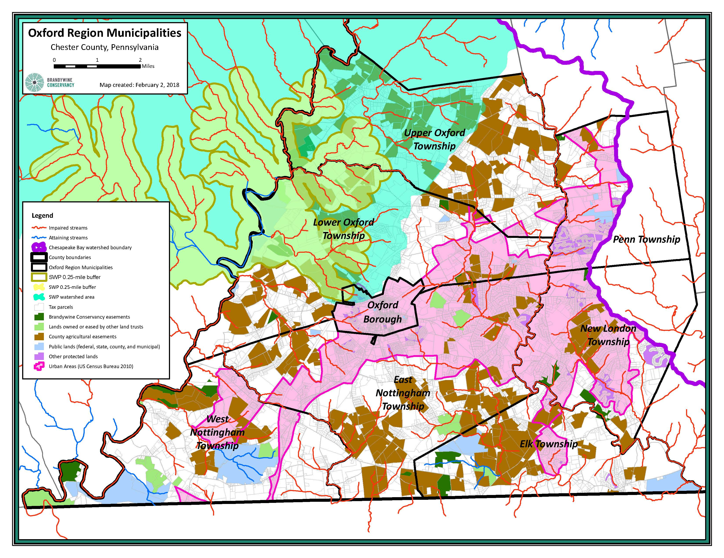

Findings from Existing Programs/Projects
In February 2019, the project team invited local partner organizations and agencies that have water quality programs to present during an ORPC meeting. Jan Bowers from the Chester County Water Resources Authority introduced the evening by conveying the underlying theme of all the upcoming presentations: groundwater. Groundwater comprises the aquifers that feed into the region’s public and private drinking wells and also feeds into the region’s surface water streams. While it takes decades to see improvement, groundwater is essential to all water quality efforts. The two main Source Water Protection (SWP) plans in the region include Oxford Borough’s SWP Plan (approved in January 2018 ) for their five (5) public wells and Chester Water Authority’s plan (approved in 2015), both of which shared goals of focusing on agricultural conservation and manure management planning to improve drinking water quality in the region. The Alliance for the Chesapeake Bay and the Octoraro Watershed Association (OWA) presentations focused on current initiatives in the Octoraro Watershed in Lancaster County to improve agricultural best management practices, coupled with water quality improvement tracking through OWA’s volunteer water quality monitoring program, clean up days, buffer plantings and education and outreach efforts. Ellen Kohler and Stephanie Armpriester presented the goals of the current NFWF grant to develop a regional stormwater management strategy that incorporates both regulated and unregulated land uses and supports the municipalities in leveraging permit requirements set out in the minimum control measures.

A variety of programs are available to assist municipalities and farmers. For farmers, funding options include the Alliance for the Chesapeake Bay (Turkey Hill Clean Water Partnership and Riparian Buffer grants), Stroud Water Research Center (Farm Stewardship Program), and the Chester County Conservation District (RCPP and Growing Greener funding) for BMP implementation. Possible municipal assistance includes tapping Penn State’s Master Watershed Steward Program which trains volunteers to perform public education and outreach, invasives removal, stream monitoring, rain garden technical assistance, and stream clean-ups.

Many municipal officials were not aware of all the existing environmental partners in the Oxford Region. Most of the presentations mentioned the importance of working with farmers to improve agricultural practices in order to meet the goals of both source water protection efforts and non-point source pollution improvement initiatives. A variety of resources are available for municipal officials to partner or piggy back on existing programs to leverage municipal dollars and meet regulatory requirements more cost-effectively, such as partnering with OWA on stream cleanups, riparian buffer plantings, and public education and outreach efforts, as well as the technical assistance training that is available through Penn State’s Master Watershed Stewards Program.

The project team met several times with staff from the Chester County Conservation District to discuss stormwater management programming in the Chesapeake Bay drainage of southern Chester County. The conservation district interacts with landowners regarding the soil erosion and sedimentation control permitting process and agricultural best management practice cost-share programs. They also interact with municipalities regarding the soil erosion and sedimentation control permitting and the dirt and gravel/low volume road program. Between 2016 and 2019, one township – Upper Oxford Township – has accessed dirt and gravel/low volume road funding. During the same three-year period, there were 71 projects disturbing 1130 acres in the six municipalities that are part of ORPC requiring either an NDPES, soil erosion and sedimentation control or other permits. Given the kinds of projects included (such as utility work), these numbers do not indicate a significantly high level of development pressure.

During the same time period, the conservation district has worked with landowners in the Bay watershed to implement 36 projects on 10 farms benefiting water quality (livestock fencing, heavy use area protection, mushroom compost pads, grassed waterways, stream crossing) using funding from the Pennsylvania Department of Environmental Protection Chesapeake Bay Special Projects funding. These projects do not include those implemented using Natural Resource Conservation Service (NRCS) cost-share funding because of the privacy provision attached to that funding. We do know that at a minimum, the following projects have been implemented with Environmental Quality Incentives Program (EQIP) funding in the in the Chesapeake Bay drainage of southern Chester County:
  - 5 critical area plantings
  - 17 heavy use area protection projects
  - 19 nutrient management systems
As shared at the Connecting the Water Dots workshop in February 2019, the conservation district is also visiting every farm in the region – approximately 600 in total - to ensure that conservation plans are in place. In the Rattlesnake Run watershed, for example, there are 25 farmers and 16 of them have conservation plans in place and 4 were actively engaged in implementing BMPs. The conservation district is also has supported implementation of projects using Growing Greener funding for a stream restoration project on a farm in Lower Oxford Township, NRCS Conservation Reserve Enhancement Program (CREP) funding and Regional Conservation Partnership Program (RCPP) funding (for which the district initially received 23 applications for BMP implementation in 2019).

Land Use Data

The 2012 Census of Agriculture data show that most farms in Chester County are between 10-49 acres. Land Use/Land Cover (LU/LC) in the 52,000-acre Oxford Region is primarily agricultural (53%), with wooded (24%) and residential (15%) the next largest land use categories. This region is comprised of about 9,000 parcels, distributed somewhat evenly between 0-9.99 acres, 10-49.99 acres, and over 50 acres.

Land Use Cover | Acres in Oxford Region | Percentage of Oxford Region | Acres in urbanized area | Percentage of urbanized area
Agricultural | 27,772 | 53% | 3,316 | 33%
Wooded | 12,236 | 24% | 1,569 | 15%
Residential | 7,866 | 15% | 3,761 | 37%
Undeveloped | 1,142 | 2% | 487 | 5%
Commercial/Industrial | 679 | 1% | 458 | 4%
Institutional | 316 | 1% | 227 | 2%
Recreation | 472 | 1% | 128 | 1%
Utility | 762 | 1% | 118 | 1%
Transportation | 303 | 1% | 111 | 1%
Water | 458 | 1% | 32 | 0.3%

As the land use information presented in this table demonstrates, the majority of area in the Oxford region is an agricultural use. There are cost-share programs available through the Natural Resources Conservation Service and the Chester County Conservation District to support agricultural landowners in the implementation of water quality best management practices. In order to better understand where these programs might not hit the ground in the Oxford Region, the Brandywine Conservancy conducted a GIS analysis of smaller parcels that might not benefit from these cost-share programs, the assumption being that landowners of parcels of 5 acres and less are not able to benefit from these programs. The results are presented in the following maps.

Map of Parcels 5 acres or Less in the Chesapeake Bay drainage, Chester County
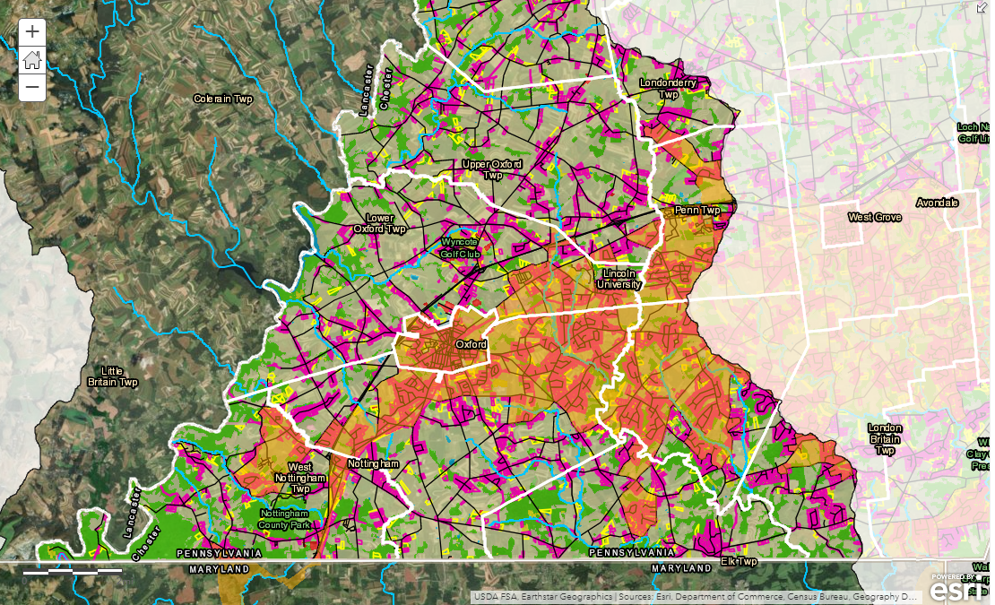

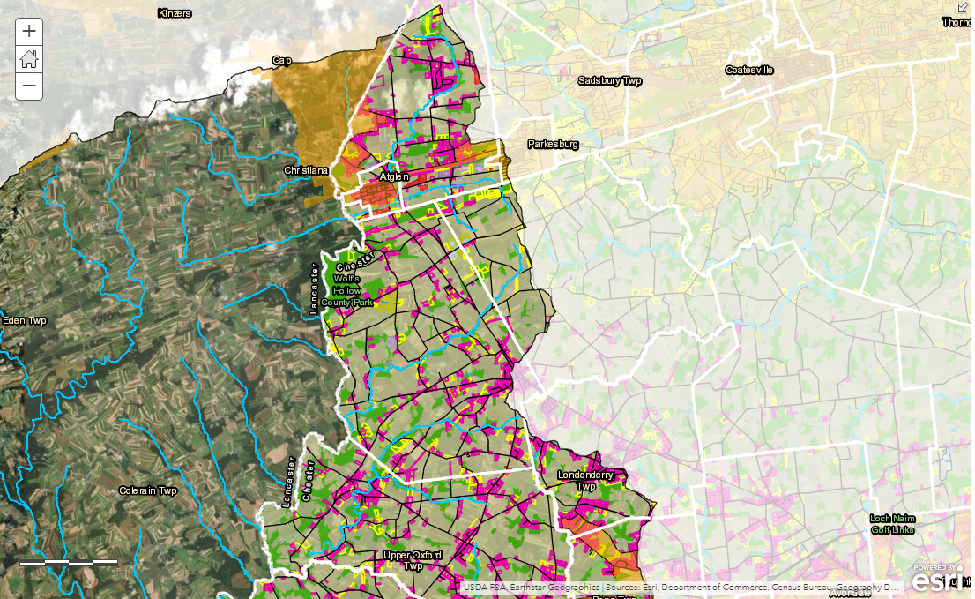

The yellow overlay in the maps represents the urbanized area. Pink parcels (turn orange in urbanized area) are 5 acres or less. The Brandywine Conservancy developed these maps. The majority of parcels (in terms of numbers) in the Chesapeake Bay drainage Chester County are five acres or less and they are in residential use. Most of these 5-acre parcels are located within the urbanized area. And there is a trend of road front lots in agricultural zones. This mapping indicates that there are a substantial number of landowners who are not within an urbanized area and who most likely are not accessing funding support from cost-share programs to implement water quality BMPs. In addition, the presence of road front lots in agricultural areas reveal sprawl trends that will have an effect on population density over time. Denser areas of the pink as shown on the map above may indicate future expansion of the Urbanized Area in upcoming permit cycles.

Parcels 5 Acres and Under
Land Use Category | Acreage
Residential | 6018
Wooded | 1192
Agriculture | 1147
Undeveloped | 291
Commercial | 253
Institutional | 92
Utility | 80
Industrial | 44
Recreation | 27
Water | 26
Transportation | 9
TOTAL | 9179

An analysis of parcels five acres or less show that there are opportunity areas to engage residential landowners. Currently there are few programs that cater to this category. Parcels five acres or less comprise 10% of the Oxford Region and the majority are located within the Urbanized Area. A concerted outreach effort to parcels of this size can result in modest reductions within the Urbanized Area. Rain gardens, rain barrels, and small riparian buffer projects are recommended BMPs for parcels less than 5 acres. Landowners on the upper end of this category who do not live off the land may be willing to implement BMPs such as riparian buffers with 35-feet or more setbacks.

Parcels Greater than 5 acres and Less than 10 acres
Land Use Category | Acreage
Agriculture | 1374
Commercial | 68
Industrial | 43
Institutional | 54
Recreation | 23
Residential | 513
Transportation | 4
Undeveloped | 120
Utility | 67
Water | 37
Wooded | 923
TOTAL | 3225

An analysis of land use greater than five acres but less than 10 show less opportunity in this area. A deep dive into the mapping showed the agricultural land reflected above is mostly being farmed with larger parcels; however, there some farmettes that may be good candidate properties for BMP implementation. This category includes produce operations and small equine operations, as well as gentleman farms that do not make a living off the land itself.

Dirt and Gravel Road Analysis
Because of the availability funding for dirt and gravel low volume roads, the Brandywine Conservancy conducted a GIS analysis of road management opportunities in the Oxford region. There are an estimated 43,203 feet (more than 8 miles) of unpaved roads and 81,700 feet (over 15 miles) of low volume roads in all six municipalities in the Oxford Region. West Nottingham has more than two miles of unpaved roads and both Lower and Upper Oxford have over a mile. Lower and Upper Oxford have over 5 miles of low volume roads.

Demographics
The table below presents a snapshot of information that can help inform our understanding of community financial capacity across the Chesapeake Bay drainage in southern Chester County. In general, these indicators show that some of the municipalities have better capacity to fund and finance the water quality improvement than others and as compared to state-wide data. However, the population and household numbers are small, making distribution of costs challenging. The two boroughs and West Nottingham have lower median household incomes and higher poverty rates. Penn Township has a very high rate of population over 65, reflecting a concentration of retirement communities in the municipality, an important consideration given that more of this population group is often on fixed incomes than other population groups.

Municipalities in the Oxford Region of Chester County, Pennsylvania
Municipality | Population | Population 65 Years + | Percent of population 65 years + | Median Household Income** | Poverty Rate*** | Total Number of Households
Atglen Borough | 1,406 | 116 | 8% | $53,802 | 11.5% | 483
East Nottingham Township | 8,877 | 847 | 10% | $94,617 | 4.1% | 2,793
Elk Township | 1,689 | 243 | 14% | $78,068 | 5.0% | 639
Franklin Township | 4,474 | 550 | 12% | $118,068 | 6.2% | 1,584
Lower Oxford Township | 5,045 | 394 | 8% | $72,308 | 11.1% | 988
New London Township | 5,903 | 578 | 10% | $120,234 | 3.8% | 1,894
Oxford Borough | 5,327 | 859 | 16% | $51,100 | 22.0% | 1,969
Penn Township | 5,504 | 1,677 | 30% | $74,335 | 6.8% | 2,281
Upper Oxford Township | 2,526 | 401 | 16% | $90,550 | 3.0% | 823
West Fallowfield Township | 2,591 | 348 | 13% | $72,645 | 4.4% | 909
West Nottingham Township | 2,721 | 380 | 14% | $57,564 | 12.0% | 906
West Sadsbury Township | 2,297 | 389 | 17% | $68,929 | 6.3% | 800
Pennsylvania |  |  | 18% | $56,951 | 13%
**Household income is based on the median income in the past 12 months (in 2017 inflation-adjusted dollars)
***Poverty rate is based on poverty status in the past 12 months (2017 data)
Stormwater Financing and Budgeting Workshop
As a result of conversations with municipal staff seeking technical assistance specific to their geography, the project partners decided to pilot a stormwater financing and budgeting workshop. The workshop was held on October 9, 2019. Municipal staff from each of the six municipalities that participate in the ORPC attended the workshop. The workshop was designed to present stormwater financing information and then focus on specific questions and strategies for municipal budgeting to be compliant with guidance from the Pennsylvania Department of Community and Economic Development.

Municipal Road Management Assessment
As a result of learning about different strategies municipalities have implemented for management of road runoff in conjunction with Pennsylvania including the dirt and gravel/low volume road program as a source for projects to reduce pollutant loads in the state’s WIIP, EFC sought a municipal partner to conduct an assessment of opportunities to implement road runoff best management practices. While several municipalities demonstrated some interest, it was discovered that the conservation district’s budget for dirt and gravel/low volume road projects was already fully allocated. If funds can be identified in the future that can be used to support this kind of assessment, it would be worth revisiting in this region.

Overall Assessment and Final Recommendations
Since 2013, the Oxford Region has benefited from its collaborative planning body, the ORPC, that involves 6 of the 12 municipalities in the Chesapeake Bay watershed of southern Chester County. The Chester County Planning Department supports the ORPC by providing a planning staff liaison. Collaboration is a financing strategy in that it helps eliminate duplication so as to free up resources for other investments, whether that is staff capacity or funding. Because of their positive experience with collaboration, these municipalities will be able to catalyze faster and more impactful water quality investments in the region. The ORPC municipalities believe that investing in water quality education and landowner engagement will be key to achieving pollutant load reductions to improve local and Chesapeake Bay water quality. To accomplish this, they support development of a voluntary regional Environmental Advisory Council (EAC). If this voluntary EAC proves successful, the ORPC members would support making it a formal municipal body.

The regional EAC will work in partnership with existing volunteer watershed groups in the area, including the Octoraro Watershed Association, the Elk Creeks Watershed Association, and the newly formed Head of the Bay Watershed Alliance. The Land Conservancy for Southern Chester County is now managing a preserve in the watershed and it is the home of the Mid-Atlantic Youth Anglers program. The Land Conservancy is interested in developing water quality education programs for landowners and residents in southern Chester County. Furthermore, it could provide administrative services for the volunteer watershed groups. Having a formal organization with staff that can help support the watershed volunteers is essential to sustained impact so the solidification of this partnership going forward is significant.

Because drinking water is the primary interest for most members of the public, it is important to note that most residents in this part of the Chesapeake Bay watershed get their drinking water from groundwater resources, including the Borough of Oxford. Nitrate levels are high and it is generally understood that the cause is agricultural land use practices, creating a direct connection between land use and drinking water quality. Water quality education materials should emphasize the groundwater connection.

The education strategy should also target landowners of parcels smaller than 10 acres and particularly with parcels 5 acres or less. As the parcel mapping research demonstrated, there are a significant number of private landowners in these categories that probably have not been reached through current municipal, CCCD or other water quality education programs. It is likely that there are several landowners with horses on their properties and there could be other groupings of landowners with common interests. Understanding these landowners, their interests and their programming needs is essential to successfully meeting local and Chesapeake Bay water quality goals.

While some of the municipalities in the region currently need MS4 permits and others soon will, the pollution reduction resulting from full compliance with these permits will not be substantial in terms of meeting WIP goals for the county. In meeting the MS4 permit requirements, municipalities manage roads throughout the region and they have revenue streams for these activities. As describe above, the project partners tried to engage a municipality in development of a road management strategy but this topic is worth revisiting.

Widespread implementation of agricultural best management practices (BMPs) that will reduce pollutant loadings from agricultural operations will be essential to meet local and WIP water quality goals. It is also important to protecting or improving drinking water quality for many residents. Since agriculture is a large part of the local economy, it is also essential that these businesses are able to thrive. Several townships in Lancaster County implemented strategies to better engage with their agricultural landowners and support their enrollment in NRCS cost-share programs to implement water quality BMPs. This engagement also helped some of the municipalities with their MS4 permit obligations. These examples need to be considered for replication in southern Chester County.

Finally, the ORPC and the other municipalities in the Chesapeake Bay watershed should do all that they can to maintain as much tree canopy cover in their communities and, ideally, expand it. There is a clear positive relationship between tree canopy cover and water quality, just as there is a clear negative relationship between impervious cover and water quality. Protecting tree canopy cover can be supported through ordinances, municipal open space programs and private land protection initiatives. As a first step, the ORPC members recently agreed to pool their resources to support having the Brandywine Conservancy map woodland resources for them. Ideally, this information will support a discussion about how to best protect and increase the amount of woodland area in the region.

Invest in education
- Build on the successful partnerships to staff first Fridays in Oxford Borough
- Octoraro Watershed Association, Elk Creeks Watershed Association and Head of the Chesapeake Alliance to promote stream cleanups and monitoring activities, expanding throughout Chesapeake Bay drainage in Chester County
- Target audiences for water quality education programming should include farmers, large landowners, equine operations, municipal staff and elected officials
- Seek out grant funding to support additional joint educational programming

Financing strategy: Identify grant funding and volunteer staffing

Integrate across water resource initiatives
- Coordinate with Chester Water Authority and Oxford Borough’s Source Water Protection programs
- Leverage Alliance for the Chesapeake Bay work with farm co-ops to engage more farmers in southern Chester County
- Engage Pennsylvania Extension master watershed stewards
- Review wellhead protection ordinances to understand how source water protection and land use ordinances may be impacting groundwater

Financing strategy: identify organizational lead and funding support for sustained engagement

Capitalize on road management opportunities
- Prioritize BMP implementation for gravel and low volume roads that impact streams and water quality
- Prioritize BMP implementation on stream crossings throughout the Chesapeake Bay drainage
- Prioritize BMP implementation on roads that flood during storm events
- Adopt “Dig Once” strategy for all road projects
- Partner with the Pennsylvania Department of Transportation (PennDOT) to identify problems and solutions related to PennDOT roads
- Support municipal training to implement road management activities

Financing strategy: Leverage dirt gravel / low volume road funding liquid fuels tax revenue another road funding to address identified priorities; leverage PennDOT funding to implement BMPs; seek grant funding to support initiation of strategy

Support implementation of agricultural BMPs
- Educate residents about BMPs that agricultural community is implementing
- Partner with farmers in and around the urbanized area to implement agricultural BMPs
- Partner with drinking water purveyors to communicate with residents about nitrate issues in groundwater supplies
- Support program funding for agricultural BMPs
- Coordinate with Lancaster County an agricultural BMP training and implementation

Financing strategy: Use existing funds to communicate with residents; partner with drinking water purveyors and CCCD on agricultural BMP education programming

Target private landowners of parcels 1 – 10 acres not often served by NRCS cost-share programs
- Identify equine operations in the Chesapeake Bay drainage
- Target education and outreach to private landowners outside the urbanized areas in the region, including equine operators and horse owners.
- Partner with CCCD on education programs about NRCS programs that large-lot landowners can use to support implementation of water quality BMPs on their properties

Financing strategy: Identify grant funding to build out program at CCCD

Consider joint capacity structures
- Engage potential partners in discussions about public education programming and HOA education, training and inspections
- Consider different structures including but not limited to:
  - Circuit rider model
  - County watershed MS4 coordinator
  - Regional Environmental Advisory Council
- Select preferred option and develop work plan and other documentation to support structure(s)

Financing strategy: Identify grant funding to support initiation of structure(s)

Protect existing forest cover
- The more tree cover, the better for water quality
- Adopt and/or revise ordinances to protect existing forest cover and forested riparian buffers
- Support open space acquisition of forested areas and forested riparian buffers
- Educate residents about importance of forest cover and forested riparian buffers to water quality
- Support tree planting projects to reforest areas within the Chesapeake Bay drainage by providing letters of support for grant applications

Financing strategy: Use existing funding to review ordinances an adopt new or revised ordinances and identify open space acquisition opportunities; include importance of forests and forested riparian buffers in resident education programming

