MEMORANDUM
TO: Lebanon County Stormwater Consortium
FROM: Ellen Kohler, Environmental Finance Center, University of Maryland
RE: Recommendations regarding Operations and Maintenance of Stormwater BMPs based on the 2019 Action Plan
DATE: November 16, 2018

Introduction

In order to comply with the Pennsylvania Department of Environmental Protection’s (PA DEP) Municipal Separate Storm Sewer System (MS4) program, Lebanon County Stormwater Consortium submitted its Joint Pollution Reduction Plan (PRP) accompanied by an intergovernmental cooperation agreement designed to support implementation of stormwater best management practices (BMPs) in fall 2017. To facilitate continued cooperation around plan implementation, the Environmental Finance Center is providing support to the consortium regarding financing of the operations and maintenance (O & M) aspects of the joint plan.

As the members of the consortium are aware, there are multiple components to a stormwater management program, including:

- Public education and involvement
- Administration
- Engineering and planning
- Capital improvements
- Operations and maintenance of facilities
- Technical support
- Billing, budgeting and finance
Stormwater programs present organizational and political challenges. Responsibilities can be dispersed across a large group of people and multiple departments, agencies, and organizations. Capital costs can be large. Municipalities may not have the capacity in house to address the specific scientific and water quality issues involved or to maintain stakeholder education and engagement efforts. In addition, the regulatory landscape in Pennsylvania continues to evolve.

From a financing perspective, the goal is to develop a strategy that supports the municipalities’ budget needs. The first step is identifying appropriate funding sources for specific program components. For example, a municipality might choose to use different revenue sources for different program components as outlined in the table below.

POSSIBLE FINANCING STRUCTURE
GENERAL FUNDS | GRANT | PARTNERSHIPS | FEES
Staff costs | Demonstration BMP projects | Education and outreach | BMP project implementation
Engineering | Initial stormwater management support | GIS services | Long-term stormwater management
Monitoring | Education and outreach | BMP project implementation | Operations and maintenance
Asset management
Training and IT support

General Information about Other Stormwater Collaborations

Several municipal collaborations, including the Lebanon County Stormwater Consortium, have formed in Pennsylvania over the last few years with the goal of addressing water quality impacts related to stormwater runoff. In general, they have focused on reducing sediment loads as a result of implementation of sediment total maximum daily load (TMDLs) in various watersheds coupled with the regulatory requirements of the MS4 program. Table 1 below provides some information about some of these collaborations. The first three collaborations involve counties covered by the Chesapeake Bay Sediment TMDL. The last two involve watersheds outside the Chesapeake Bay watershed.

Table 1. Comparison of Stormwater Collaborations in Pennsylvania

 | No. of munis | Sediment Load Reduction Target (lbs/yr) | No. of Projects | Total Funds under Agrmt | Cost Share formula | Term of Agrmt
York County Stormwater Consortium | 45 | 2,443,984 (10% of TMDL reduction requirement) | 77 | $13 million  (based on project cost estimates reduced by 20% assumed savings) | 20% impaired stream miles  30% population  50% impervious | 5 years
Blair County Intergovernmental Stormwater Committee | 11 | 1,409,613 (10% of TMDL reduction requirement) | 43 | $200,000  (based on agreed upon amount) | 20 % stream length in UA  30% population  50% impervious cover | 2 years
Wyomissing Creek Watershed Coalition | 8 | 372,986  (10% of existing load)* | 7 | $1,522,600 (based on estimates of project costs) | In process of revising | 5 years
Eastern Delaware County Stormwater Collaborative | 10 | 356,202 Darby Creek  208, 241 Cobbs Creek (10% of existing loads) | 75 (Darby Creek)  39 (Cobbs Creek) |  | Equitable share based on municipal percentage of existing load; equal shares for admin costs | 5 years
Honey Brook Borough and Township  (Central Planning Area only) | 2 | 1350 lbs/yr (10% of existing load)* | 3 | $51,587 estimated project costs; also sharing admin and O & M costs | 80% Borough  20% Township based on needed reductions | 5 years

The PA DEP TMDL plan requirements for TMDL areas outside the Chesapeake gave municipalities the choice of addressing either 10% of the existing sediment load to the stream OR addressing the municipal sediment waste load allocation (WLA) as set out in the TMDL. Because the Chesapeake TMDL does not include WLAs by municipality, the only choice for Chesapeake municipalities was to address 10% of the existing sediment load.

There are some common elements to many of these collaboratives:
- Support of county administrative assistance with costs shared by parties;
- Use of a common load calculation methodology and GIS mapping (required for MS4 permit approval);
- Governing body with representatives from each municipality;
- Adoption of a relatively simple funding formula;
- Establishment of accounts for municipal financial contributions; and
- Shared commitment to seek grant funding.

Some of these collaborations began before the current MS4 permit cycle. The Eastern Delaware County Stormwater Collaborative formed to help the municipalities met the public education and outreach requirements of the MS4 program. Similarly, the Christina Watershed Municipal Partnership, which supported the work that resulted in the Honey Brook Collaborative Plan, has been providing public education and outreach to municipalities in the Christina Basin since 2003. The collaborations with the most experience to date in implementing BMPs would likely be York County and the Wyomissing Creek Watershed Coalition.

Operations and Maintenance Activities

In general, operations in the context of a stormwater program includes administration, management and non-maintenance activities necessary to keep BMPs safe and functioning. These activities would include BMP planning, BMP inspections (regular and after significant weather events), scheduling maintenance, annual reporting, and staff training.

Maintenance activities are those that ensure that individual components and structures of stormwater facilities and systems are achieving their objectives in terms of safety and function. Examples would include vegetation management, repair of damaged components, and replacement of failed components.

Unfortunately, there is not significant literature about the costs of conducting stormwater O & M activities. Estimates range from 1 -7% of project costs.

The Joint PRP and O & M Activities

In the case of the Lebanon County communities, the intergovernmental agreement that forms the basis of the consortium states that the member municipalities agree to work together on annual action plan development and BMP implementation. It also makes clear that the members intend that the agreement includes conducting and funding activities related to operations and maintenance of BMPs implemented under the agreement. The details related to operations and maintenance will be addressed in a separate agreement on a project-by-project basis.

The Joint PRP includes a list of proposed projects to meet the required pollutant load reductions for sediment, nitrogen and phosphorus during the term of the MS4 permit. The majority of these projects are stormwater basin retrofits and streambank restoration projects.

With respect to the stormwater basin retrofits, the majority of these proposed projects are on private land. It is the intention of the consortium that the private landowner(s) will be responsible for regular maintenance and the consortium members would be responsible for major fixes, including total failures. Operations relating to inspections and annual reporting would be conducted by the consortium. There are 30 stormwater basin retrofits included in the plan. The average cost across those projects is $21,433 for a total of approximately $643,000. Using the budgeting recommendations from the literature, O & M costs are estimated at $214 to $1500 per project based on the average with a mid-point at $857.

Stormwater basin retrofits | Project Costs | 1 – 7 % O & M Cost
30 projects | $21,433 average  $643,000 total | $214 to $1500 per project  $ 857 average

With respect to streambank restoration projects, the responsibilities for regular maintenance may depend on landownership where the project is to be completed and/or partnerships with other entities. It is assumed that operations relating to inspections and annual reporting would be conducted by the consortium. The plan includes 12 streambank restoration projects. The average cost across those projects is $565,000 and the total is $6,780,000. Using the budgeting recommendations, the O & M costs should be estimated at $5650 to $39,550 per project based on the average with a mid-point at $22,600.

Streambank Restoration | Project Costs | 1 – 7 % O & M Cost
12 projects | $565,000 average  $6,780,000 total | $5650 to $39,550 per project  $22,600 average

The Consortium’s Annual Action Plan for 2019 is based on a $200,000 budget for implementing approximately 10 stormwater basin retrofit projects. The plan also suggests initiating planning for streambank restoration projects to be implemented in 2020. It is assumed that the planning costs related to these streambank restoration projects are not included in the $200,000 budget.

Since 2019 represents the initial implementation year, there will be no maintenance costs related to BMPs implemented through the consortium. However, there will be operation costs, particularly around BMP planning and reporting for the stormwater basin retrofit projects. Outreach to landowners has begun and, of the four landowners contacted to date, two are agreeable to proceed with basin retrofits. These projects were recently were approved for grant funding; however, the grant program did not allow for the costs of operations and maintenance to be included. Given that the annual action plan suggests implementing 10 basin retrofits, using the mid-point estimate for O & M costs of $857, it would be appropriate to budget approximately $8570 for operation costs for 2019 though the actual expense will likely be less because of the lack of maintenance needs.

The annual action plan includes more than 10 projects in the event that some landowners are not willing to participate. The distribution in terms of location of all projects is set out in the table below, with a comparison to the consortium’s cost share percentages.

Municipality | No. of basin retrofits in 2019 Annual Action Plan | Percentage of total | Consortium Cost Share percentage
City of Lebanon | 0 | 0% | 35%
Borough of Cleona | 3 | 10% | 3%
Annville Twp | 3 | 10% | 8%
South Lebanon Twp | 4 | 14% | 17%
North Lebanon Twp | 7 | 24% | 21%
North Cornwall Twp | 12 | 41% | 16%

Funding the O & M activities related to basin retrofits going forward is one question that needs to be resolved among the consortium members. Some of the additional questions to be addressed to have a more complete understanding among members of how O & M will be managed include:

- Is there a municipal/landowner agreement that addresses O & M responsibilities? If not, one will need to be drafted.
- What activities would be included in “regular” maintenance for landowner to complete?
- How is “major fix” defined?
- Who is going to do operations – planning, inspections, reporting?
- Who is going to do maintenance in the future if “major fix” needed?
- How should maintenance be paid for? By individual municipalities? If so, would the expenses be considered part of their cost share or would they be paid for outside of their cost share?
- Is there a member municipality that is well-situated to handle operations activities? Is there a member municipality that is well-situated to handle maintenance activities?
- If the member municipalities are not going to manage O & M themselves, would there be cost savings in having centralized operations and/or maintenance activities through a contractor?
- The MS4 permit requires annual reporting on several activities in addition to O & M, such as BMP implementation and public education. Are the member municipalities partnering on other activities related to their MS4 permits outside of the PRP plan, such as any of the minimum control measures (MCMs)? If not, is there interest in partnering on those activities in addition to the annual reporting required for BMP implementation and O & M? Would there be cost savings in partnering on these activities? If so, is there a municipality that is well-situated to coordinate and report on these activities?

Many of these activities are not time-intensive or costly. However, it is important to work through these questions and consider the activities that the member municipalities will have to engage in each year and throughout the full permit period to ensure that all activities are identified and responsible parties are assigned. It will also help ensure a more accurate budget for both the consortium and individual municipalities.

The consortium members raised concerns about the significant costs that could arise as the result of a failure of a streambank restoration project. As noted, initial implementation of these projects is expensive and, given the large storm events and significant flooding issues that occurred this past summer in the region, it is entirely possible that these projects could be jeopardized, putting at risk the consortium’s substantial investment. This possibility counsels for careful project planning to ensure that upstream volume and flow have been properly reduced before moving forward with the streambank restoration project. Members asked if there was insurance for these kinds of expensive green infrastructure projects. Our preliminary investigation indicates that there is not an existing insurance vehicle designed to protect this kind of investment.

The stormwater basin retrofits, in contrast, are much less expensive to implement, making the challenge of addressing a potential failure of an individual basin much less of a financial burden. The members also discussed the benefits of having dispersed stormwater features throughout the community so as to reinforce the idea that everyone needs to do their fair share to manage stormwater as opposed to concentrating BMP implementation in a few locations. Nonetheless, it would be wise financial planning to consider maintaining a healthy O & M fund to be able to address the challenge that could arise from having multiple basins fail in one drainage area as the result of a large storm event.

Stormwater Control Management

An essential aspect of operations and maintenance is tracking the information needed to efficiently and effectively conduct those activities. Many communities use asset management systems to manage information about their stormwater BMPs. These systems can range from well-constructed spreadsheets to software products designed for just this purpose. Because the consortium will be working across different municipalities and potentially different contractors, agreeing on what information to collect and how to collect it needs to be addressed at the outset. The information collection and management should be adaptive and self-informing to improve efficiency and predict costs more accurately. The following diagram identifies chief strategies in managing assets over time, beginning with creating a system inventory. 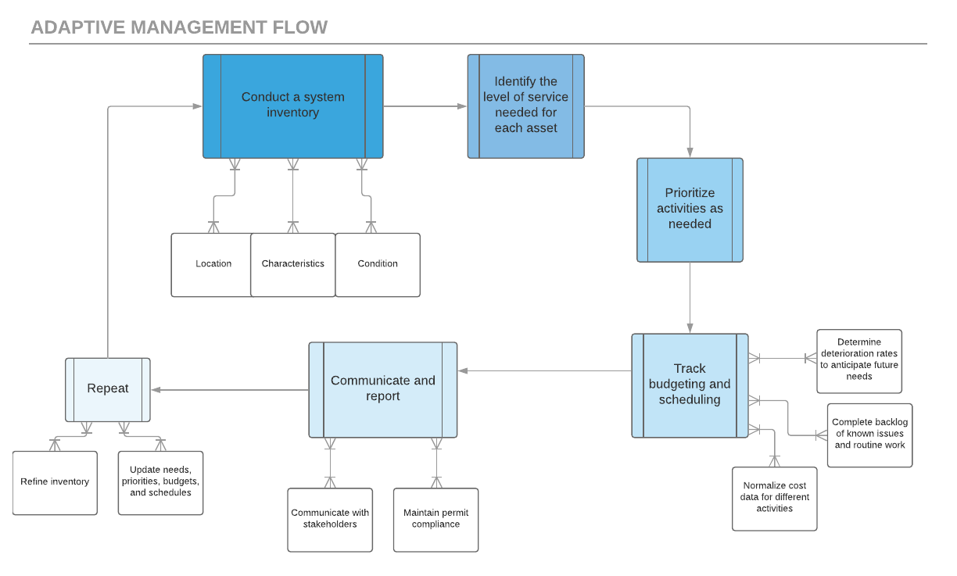

Asset Tracking
The management framework of a stormwater system should include inventory, budgeting, and scheduling tracking. Specific controls should be used as measurement tools, such as volume of water retention or pollutant load reductions. Other qualifying factors may impact how a site functions and may not be truly representative of a site’s capacity.

A system inventory is the first step to collecting basic information about stormwater control assets. This list is consistent with current DEP reporting requirements and includes:

Parameter | Description
BMP Name | General facility name
BMP Type | Bioretention, grass swale, grass buffer, tree planter, permeable pavement, composite, etc.
City and State | Allows for geographic comparisons; latitude and longitude
Date Installed | Allows tracking of maintenance cost over time
Land Area | Size of drainage area
Percent Impervious | Percent of impervious cover v pervious cover for drainage area
Surface Area | Footprint of the facility; length and width
Vegetation Information | Number and species of trees/shrubs; high maintenance, moderate maintenance, low maintenance, native grasses, turf, wetland, not applicable, etc.
Treatment Volume | Provide volume of water treated
Site Loading Intensity | High, moderate, low
Facility Ownership | Public, private, etc. ; if privately owned, name and address of landowner

Tracking costs may be more difficult, as activities may be carried out by multiple departments or volunteers. Information should be gathered in a centralized way to allow for comparison of performance and budgeting. Maintenance costs will vary from year to year depending on what kind of maintenance has been carried out and site characteristics. To gain a true understanding of the benefits of the infrastructure, costs should be normalized and correlated with the above parameters. Consideration should also be given to how costs may change over time; bioretention may need less irrigation as vegetation matures, for example. A list of maintenance and cost tracking values may contain:

Maintenance Event Records | Description
Asset Performance Status | Normal, failing, unknown
Maintenance Type | Inspection, routine, restoration/reactive, rehabilitation, other
Maintenance Entity | Contractor, municipal, volunteer, combination
Maintenance Date | Documents frequency and allows for normalization of data over time
Maintenance Narrative | Mowing, irrigation, structural repair, plant replacement, etc.
Total Cost | Total overall cost
Cost Type | Flat fee, time and materials
Labor Cost | Total labor cost
Labor Time | Time required to complete maintenance/site visit
Materials Description | Plants, mulch, media, hardscape, chipping materials, etc.
Materials Cost | Cost of materials
Equipment Description | Vacuum sweeper, shovel, backhoe, etc
Equipment Ownership | Owned, rented, contractor
Equipment Cost | Rental cost or owner cost
Disposal Cost | Cost of materials disposal, if applicable
Administrative Cost | Cost of scheduling and tracking maintenance
Other Cost | Additional costs not included above, if applicable

In order to have a better sense of the costs of operations and maintenance and to support more accurate budgeting, it is advisable that a common system for tracking BMPs and the costs and nature operations and maintenance be adopted by all of the consortium member municipalities.

Conclusion

In summary, the Environmental Finance Center makes the following general recommendations regarding the consortium’s stormwater program’s operation and maintenance (O & M) activities:

- Consider the full life cycle and replacement costs in planning and implementing BMPs;
- Assess BMP implementation projects beginning at the top of a drainage area and moving downstream to better address impacts resulting from flow and volume;
- Include O & M costs in the consortium’s annual budget;
- Identify responsible parties to conduct O & M activities;
- Track information about BMP implementation and O & M activities consistently across consortium municipalities; and
- Look for opportunities to collaborate on O & M activities among the consortium members and with other stakeholders, such as watershed groups or land conservation organizations, to reduce municipal costs.
The Lebanon County Stormwater Consortium and its members have developed a strong partnership, implemented a well-designed initial financing structure, and engaged in thoughtful and important discussions about program implementation and sustainability. It is a model that other communities can look to for guidance as they tackle similar stormwater management challenges.

Dennis King and Patrick Hagan, Costs of Stormwater Management Practices in Maryland Counties, University of Maryland Center for Environmental Science, October 10, 2011; Colorado Emergency Watershed Protection Program, Operations and Maintenance Fact Sheet, May 2016 at http://coloradoewp.com/document/fact-sheet-operations-and-maintenance; Jane Clary and Holly Piza, editors, Costs of Maintaining Green Infrastructure, American Society of Civil Engineers, 2017.
VHB, Asset Management for Stormwater Infrastructure, MS4 Training Resources, 09 Feb. 2018.
Clary and Piza at 71-77.
Id.

