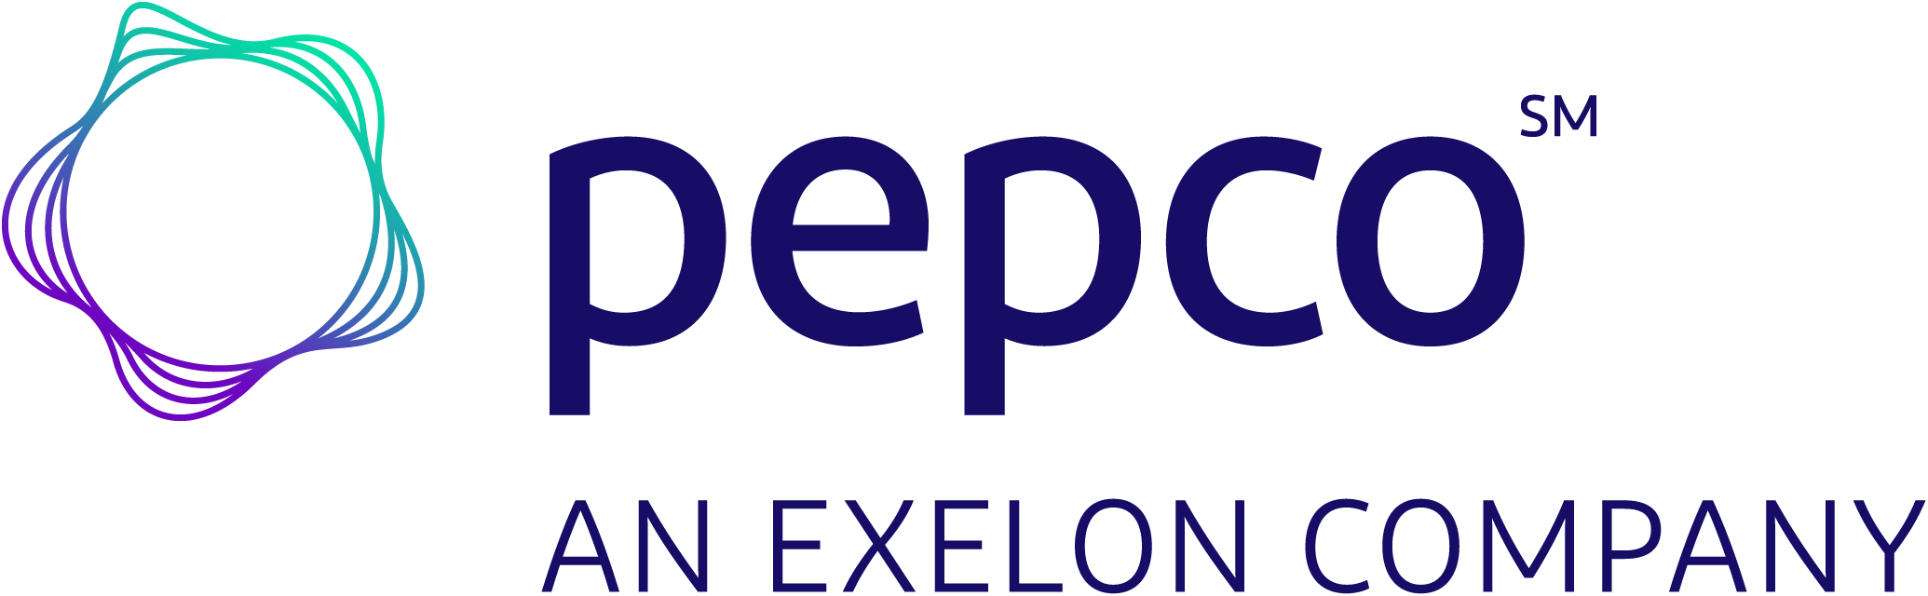

|  |  |  |  |
| --- | --- | --- | --- |
| **Contact:** | Chuck McDade  Pepco Communications  202-872-2680 (media hotline) | Liv Pierce  Sustainable Maryland 617-818-7734 | for immediate release |

**Pepco and Sustainable Maryland Invest $125,000 in Ten District of Columbia and Maryland Communities, Municipalities and Nonprofits to Bolster Open Space and Resiliency Efforts**

*Funding will support local projects for environmental preservation, park enhancements, community resiliency and more*

**WASHINGTON, D.C.** (Oct. 4, 2024) – Pepco and Sustainable Maryland announced the ten recipients of the 2024 Sustainable Communities Grants Program, a key initiative dedicated to investing in the region’s future. With a total of $125,000 in one-time grants, this program supports vital projects across the District of Columbia and Maryland that preserve the environment and improve parks by restoring native pollinator species and increase access to essential resources like local produce and emergency medical equipment.

"Pepco is a proud environmental steward, and we’re committed to giving communities and nonprofits in the District and Maryland, the tools and resources they need to turn our shared climate goals into reality," said Valencia McClure, Pepco Region President. "The more we invest in sustainable projects, the closer we get to creating a cleaner, brighter future and enhancing the quality of life in our communities for everyone.”

Since its launch in 2020, Pepco’s Sustainable Communities Grant Program has invested $600,000 in grants to support environmental, open space and resiliency efforts in the communities where Pepco serves.

“These grants allow our awardees to proactively address environmental challenges with projects they would not otherwise be able to take on,” said Jen Cotting, Director of the Environmental Finance Center. “This partnership with Pepco is crucial to building local resilience in our region."

This year, Pepco and Sustainable Maryland have awarded grants to the following municipalities:

* **Town of Colmar Manor ($10,000)** – The grant will support volunteers in removing invasive species from the local Dueling Creek.
* **Friends of Lower Beaverdam Creek ($10,000)** – The grant will create a sustainable community meadow in Cheverly using native pollinator species.
* **Friends of the National Arboretum ($10,000)** – The grant will improve the visitor experience and education at the Washington Youth Garden located in the grounds of the US National Arboretum.
* **City of New Carrollton ($10,000)** – The grant will fund a stormwater management project that integrates a combination of nature-based and gray infrastructure solutions for a local field in town.
* **Prince George’s County Parks and Recreation Foundation ($10,000)** – The grant will support two seasons of a farmer’s market, providing access to local produce for underserved communities in the area.
* **Town of Washington Grove ($10,000)** – The grant will fund a restoration project for the town meadow, focused on planting and restoring native pollinator species.
* **Joe’s Movement Emporium ($10,000)** – The grant will support a GreenWorks ecosystem restoration project in partnership with seven local communities to improve their tree canopy for a healthier environment.
* **Town of Berwyn Heights ($5,000)** – The grant will enable the purchase of emergency medical equipment for use in disaster response efforts.
* **DowntownDC Foundation ($25,000)** – The grant will fund solar-powered kiosks in downtown DC parks, offering charging stations for visitors that feature planters to improve air quality in the area.
* **Gift Legacy Foundation ($25,000)** – The grant will transform a storage container into an off-grid environmental agriculture education classroom for local community members and students.

Pepco's Sustainable Communities Grant Program supports municipalities, recreational authorities, and nonprofits in the Pepco service area and can apply for a Sustainable Communities grant each year. A committee featuring representatives from Pepco, the University of Maryland, and nonprofit and state agencies evaluate applications and select the projects to receive funding.

The program is part of Pepco’s Climate Commitments in the [District of Columbia](https://www.pepco.com/SafetyCommunity/Environment/Pages/PepcoClimateAction.aspx) and [Maryland](https://www.pepco.com/SafetyCommunity/Environment/Pages/PepcoClimateActionMD.aspx). As part of this commitment, the company is implementing measures to reduce its greenhouse gas footprint while providing innovative solutions to empower customers and communities to achieve greater greenhouse gas reduction. The effort supports the broader [Path to Clean](https://www.exeloncorp.com/sustainability/Documents/Path_To_Clean_Overview.pdf#search=path to clean) goal of Pepco’s parent company, Exelon, to reduce its operations-driven emissions by 50 percent by 2030 and achieve net-zero operations by 2050.

To learn more about Pepco, visit [The Source](https://thesource.pepcoholdings.com/opco/pepco/), our online newsroom. Find additional information by visiting [pepco.com](https://www.pepco.com/Pages/default.aspx), on Facebook at [facebook.com/PepcoConnect](https://www.facebook.com/PepcoConnect/) , and on Twitter at [twitter.com/PepcoConnect](https://twitter.com/pepcoconnect). Pepco's mobile app is available at [pepco.com/MobileApp](https://www.pepco.com/MyAccount/CustomerSupport/Pages/MobileApp.aspx).

# # #

**About Pepco:**

*Pepco is a unit of Exelon (Nasdaq: EXC), a Fortune 250 company and the nation’s largest utility company, serving more than 10 million customers. Pepco provides safe and reliable energy service to approximately 919,000 customers in the District of Columbia and Maryland.*

**About Sustainable Maryland:**

*Sustainable Maryland is a free and voluntary certification program designed to help Maryland municipalities become more sustainable by implementing best practices that address the needs and interests of their community. The program provides a wide range of free resources including detailed guidance, tools, training, technical assistance and grants. Currently, 88 municipalities are participating in the municipal certification program.*